Compulsory Question 1:
Question 1. [10 marks]

Consider the following grammar:

S → Session $
Session → Facts Question
Session → ( Session ) Session
Facts → Fact Facts
Facts →
Fact → ! string
Question →? string
- Calculate nullable, FIRST and FOLLOW for this grammar: [5]

- Construct the LL(1) parsetable. [4]

- Why is this grammar a LL(1) grammar? Give reasons for your answer by referring to your LL(1) parsetable. [1]

Answer:
- nullable, FIRST and FOLLOW:

 | nullable | FIRST | FOLLOW
S | no | ( ? ! |  | √
Session | no | ( ? ! | )$ | √
Fact | no | ! | ! ? | √
Facts | yes | ! | ! | √
Question | no | ? | )$ | √

b) LL(1) parsing table

 | ( | ) | $ | ! | ? | string
S | S → Session $ |  |  | S → Session $ | S → Session $
Session | Session → ( Session ) Session |  |  | Session → Facts Question | Session → Facts Question
Fact |  |  |  | Fact → ! string
Facts |  |  |  | Facts → Fact Facts  Facts →
Question |  |  |  |  | Question ? string

1/2 mark for each correct entry, max 4 marks.

c) This is not a LL(1) grammar because there are duplicate entries in the LL(1) parsing table. ( 1mark)

Choose between Question 2 and Question 3 below:
Question 2 [10 marks]

a) Construct the LR(0) and SLR parsetables for the following grammar and its given LR(0)-DFA: [10]

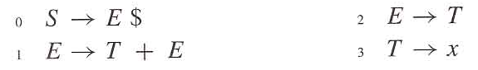

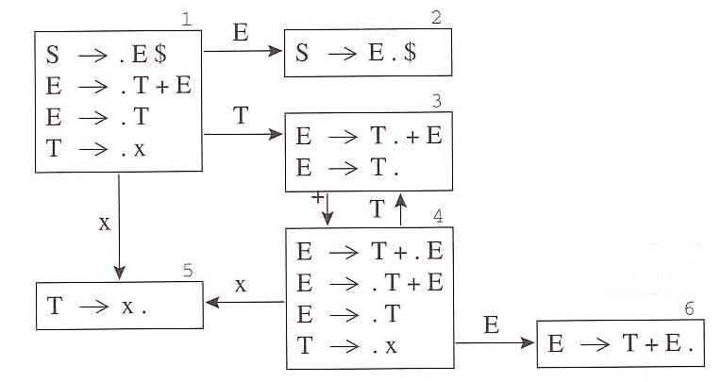

Answer:

LR(0) Parsetable

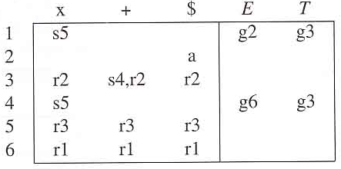

One mark for each correct row (excluding accept)

SLR Parse Table

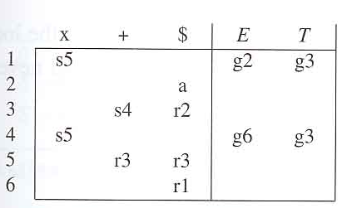

One mark for each correct row (excluding accept)

Question 3. [10 marks]

- What is the difference between a Concrete Parse Tree and an Abstract Parse Tree? [2]
Answer : Concrete Parse Tree – represents the concrete syntax of the source language. Abstract Syntax – conveys the phrase structure of the source program with all parsing issues resolved but without any semantic interpretation.
- Consider the grammar below describing the abstract syntax of expressions.

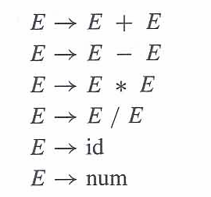
Describe the Visitor Pattern. Supply the java code for the grammar above to illustrate this design pattern [8]
Answer: A visitor implements an interpretation – an object that contains a visit method for each syntax tree class. Each syntax tree class contains an accept method. An accept method serves as a hook for interpretations. It is called by a visitor class, and passes control back to an appropriate method in the visitor class. It allows the addition of a new interpretation without editing and recompiling existing classes, providing that each of the appropriate classes has an accept method, etc ….
Mark code on discretion.

